**[HTG Explains: What Is BIOS and When Should I Use It?](http://www.howtogeek.com/179789/htg-explains-what-is-bios-and-when-should-i-use-it/" \o "HTG Explains: What Is BIOS and When Should I Use It?)**

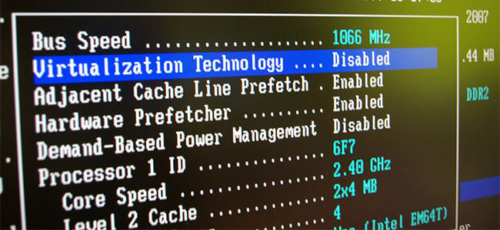

The BIOS on your computer is essential for it to function, yet it remains behind the scenes. In this article, you will discover what this hidden software does, and the reasons why you may need to access it someday.

What is BIOS

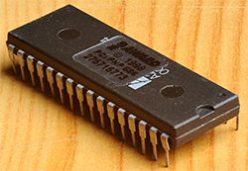  
[BIOS](http://www.howtogeek.com/glossary/bios/) stands for Basic Input/Output System and is a set of instructions stored in a firmware chip on your computer’s motherboard.

The BIOS on your computer controls some of the most essential functions that we take for granted, such as loading the drivers for your peripherals (mouse, keyboard, USB drives, etc), going through boot order and initializing your hard drives, displaying output on your monitor, and other things.

How to access BIOS

You can poke around your BIOS settings even if you don’t really know what you’re doing, just be careful not to change anything. When your computer first starts up, you can usually access BIOS by pressing the delete key. Some manufacturers may use different keys, but either way it should tell you when your computer first starts up.

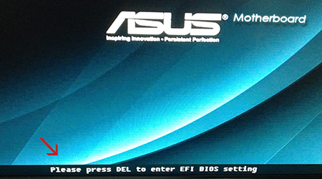

UEFI vs. traditional BIOS

Before we get into explaining how to navigate the BIOS and what you can do while in those settings, you’ll need to understand the difference between the newer UEFI BIOS and traditional BIOS. Navigating through the BIOS settings is going to differ depending on what technology your computer is using.

We’ve written about the differences between [UEFI and BIOS](http://www.howtogeek.com/56958/htg-explains-how-uefi-will-replace-the-bios/) previously, but here’s a quick recap if you just want to know the highlights. The main differences that you’ll notice are that UEFI is much more user-friendly, easy to navigate, and supports the use of your mouse.

An example of a UEFI BIOS menu:

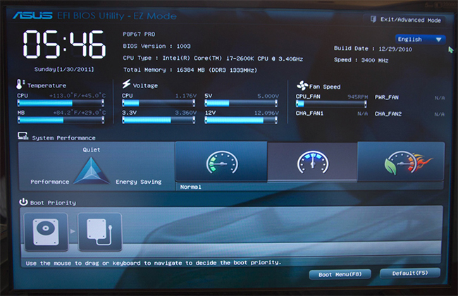

The traditional BIOS menus are much more crude and limited in configuration options. For all intents and purposes, it has been a fine system that has been around for many years, but has lately become outdated because of its imposed limitations, so all motherboard manufacturers are making the jump to UEFI BIOS.

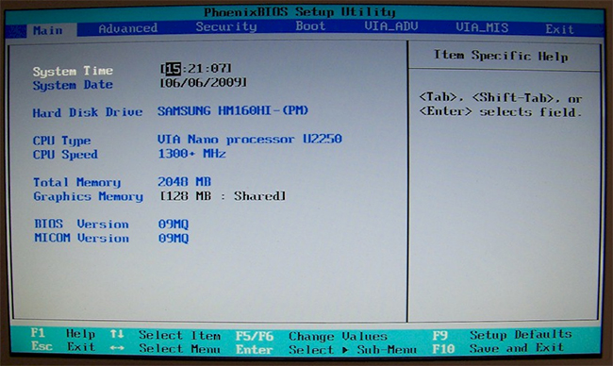

As you can see in the examples above, UEFI is a modern spin on an old technology, while also bringing some advanced features to the table (such as [Secure Boot](http://www.howtogeek.com/116569/htg-explains-how-windows-8s-secure-boot-feature-works-what-it-means-for-linux/)).

UEFI is a recent change that’s mostly come to light around the same time as Windows 8’s release, so your computer may be still running on traditional BIOS. If you are the “family geek” and fix a lot of computers, you’re likely to keep running into the old BIOS for a few years to come.

What can I do in the BIOS?

You understand BIOS, you know how to access it, but… why would you want to? All geeks need to access the BIOS at some point, as it allows for advanced system configuration that simply can’t be accessed from software (your operating system), and gives you a lot of troubleshooting options in the event that something isn’t working properly.

**Changing the boot order**

When you turn on your computer, it accesses a list of prioritized devices that it can boot from. If you have a disc in your computer or multiple operating system installations across numerous hard drives, you can change what your computer tries to boot to.

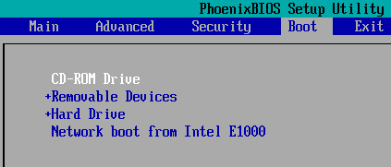

**Monitoring temperatures, fan speed, and voltages**

When experiencing problems with overheating or just checking whether or not your components are receiving the proper voltage, BIOS is the easiest place to look.

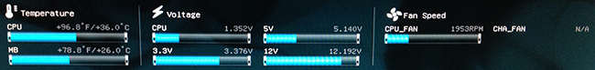

**Overclocking**

You can change your CPU clock rate and/or voltage in BIOS, effectively speeding up your computer. We have another [guide on overclocking](http://www.howtogeek.com/165064/what-is-overclocking-the-absolute-beginners-guide-to-understanding-how-geeks-speed-up-their-pcs/) if you’re interested in doing that.

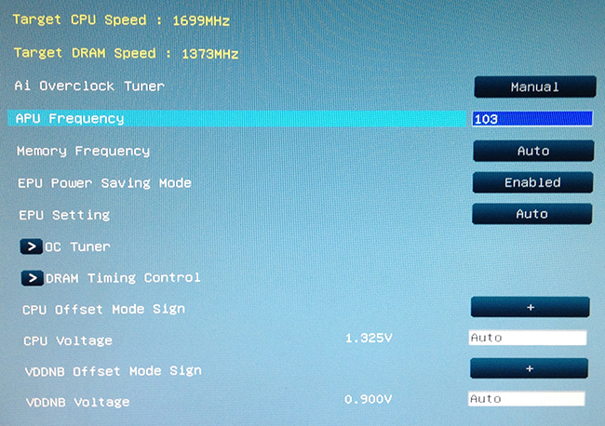

**Lock down your computer**

We mentioned Secure Boot with UEFI BIOS above, which can be used to keep unauthorized operating systems from booting. More times than not, this is probably just another hurdle that geeks have to jump over in order to tinker with their system, but it’s undeniably an essential security feature for computers with sensitive information.

**Other minor things**

The features above are the most common reasons for accessing the BIOS, but it also has other things you can do – setting the time on the system clock, choosing hardware profiles (an UEFI feature) and many other small things. Experiment for yourself so you can utilize BIOS in the future when you need to troubleshoot a problem or configure an advanced system setting.

It’s also worth your time to learn how to [reset](http://www.howtogeek.com/131623/how-to-clear-your-computers-cmos-to-reset-bios-settings/) and [update](http://www.howtogeek.com/136881/htg-explains-do-you-need-to-update-your-computers-bios/) BIOS.